Name : Sanjina talib

CMS : 023-21-0072

Project : EAD (ST COFFEE-POINT)

**Coffee Cafe** is a full-stack web application built with:

**Frontend**: React with Tailwind CSS **Backend**: Node.js + Express

**Database**: MongoDB

### ****How it works:****

* A user signs up via **/signup**, data is saved in MongoDB.
* On login, credentials are validated and a token is issued.
* On the main page, the coffee list is displayed.
* Users can select coffees and place an order.
* Cart state is managed with **useState**, and order summary is shown in a modal.

### ****Features:****

1. **User Authentication**
   * Signup with email and password
   * Login with JWT-based authentication
   * Session management with localStorage
2. **Coffee Menu**
   * Display a grid of coffee options with images, descriptions, and prices
   * “Order Now” button adds items to the cart
3. **Cart Management**
   * Add, remove, and update quantity of items
   * View total price and order summary
4. **Order Summary**
   * Modal shows a summary of the selected items
   * Thank-you message upon completing an order

***FOlDER STRUCTURE***

coffee-cafe-main/

├── backend/ # Node.js + Express + MongoDB API

│ ├── models/ # Mongoose schemas (User.js)

│ ├── routes/ # API routes (auth.js)

│ ├── controllers/ # Logic for signup/login

│ ├── .env # Environment variables (PORT, MONGO_URI, JWT_SECRET)

│ └── server.js # Express app entry

│

├── frontend/COFFEE-CAFE-MAIN # React app

│ ├── src/

│ │ ├── components/ # React compounents

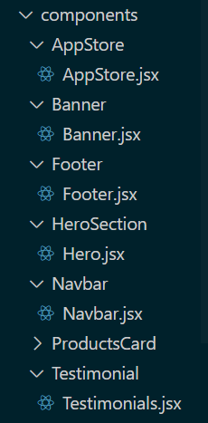

│ │ ├── App.jsx # Main app

│ │ ├── index.jsx # Entry point

│ │ └── pages: (Login.js, Signup.js, order pages)

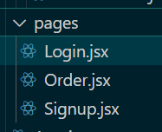

│ └── tailwind.config.js # Tailwind setup

Project :

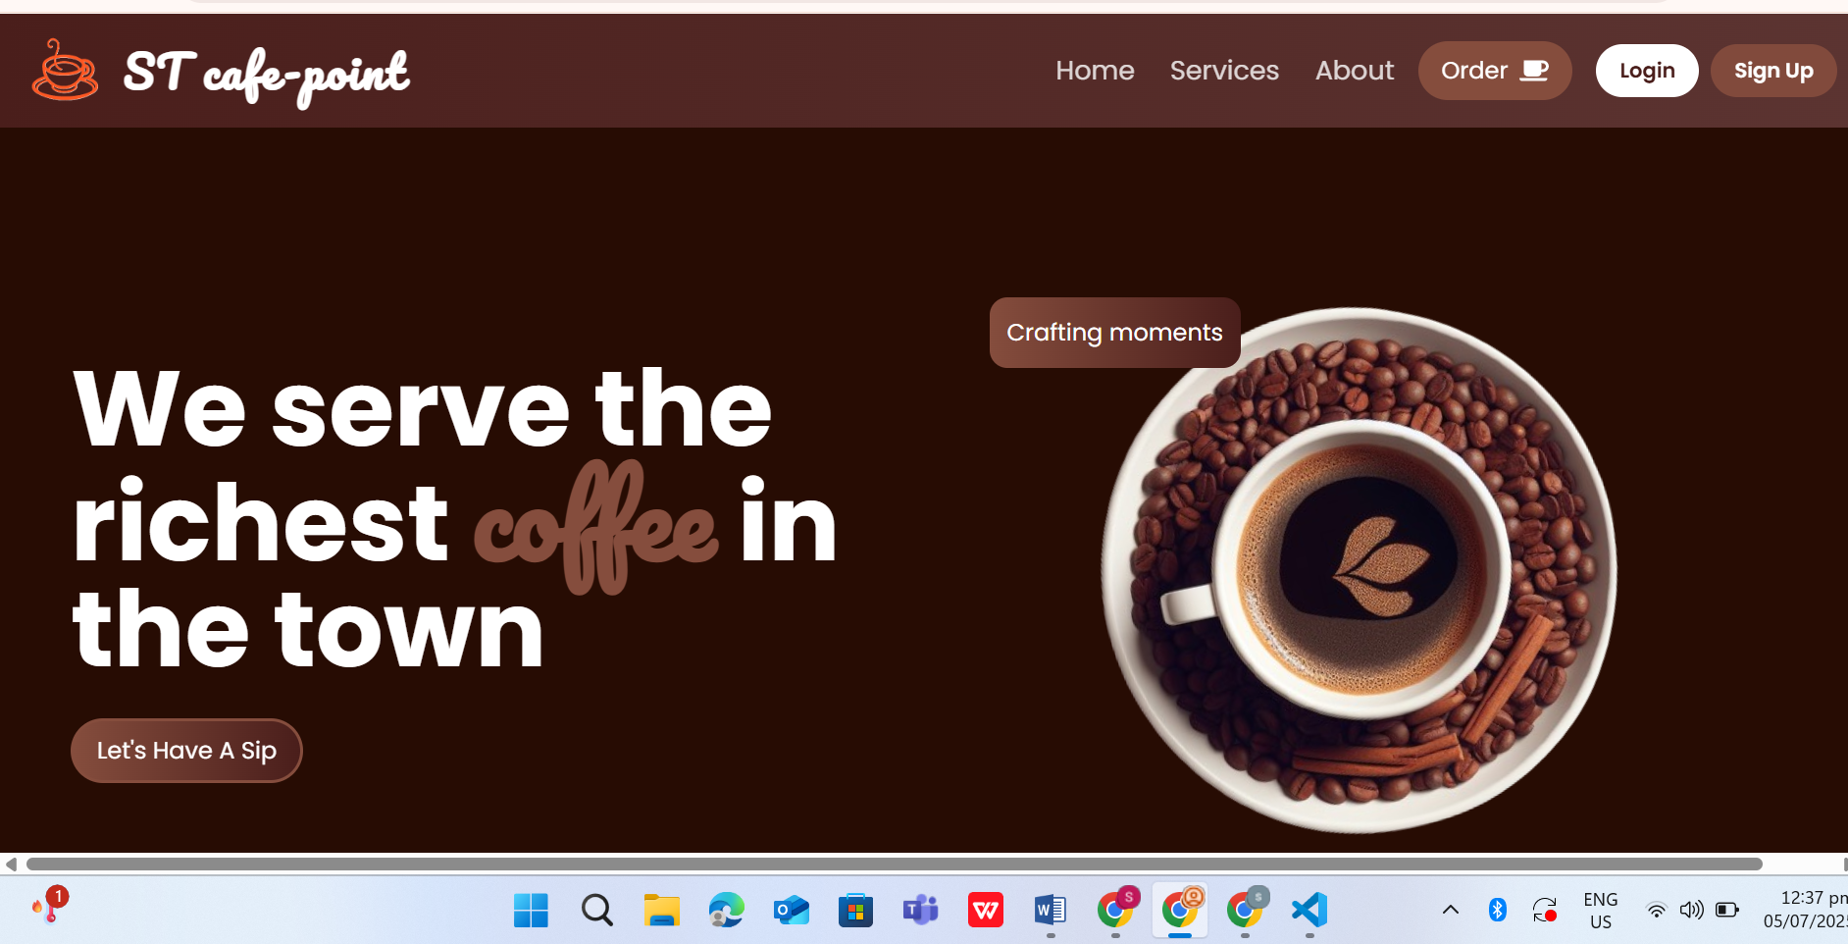

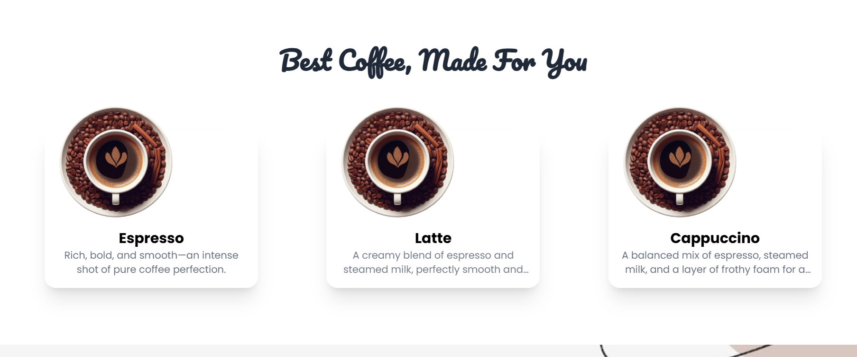



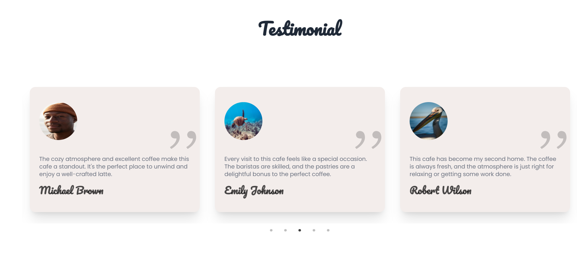

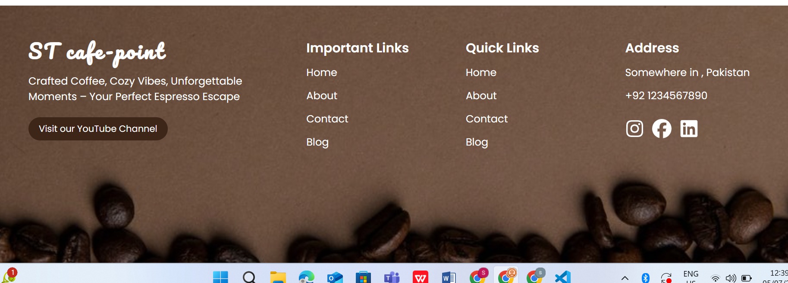

Signup page

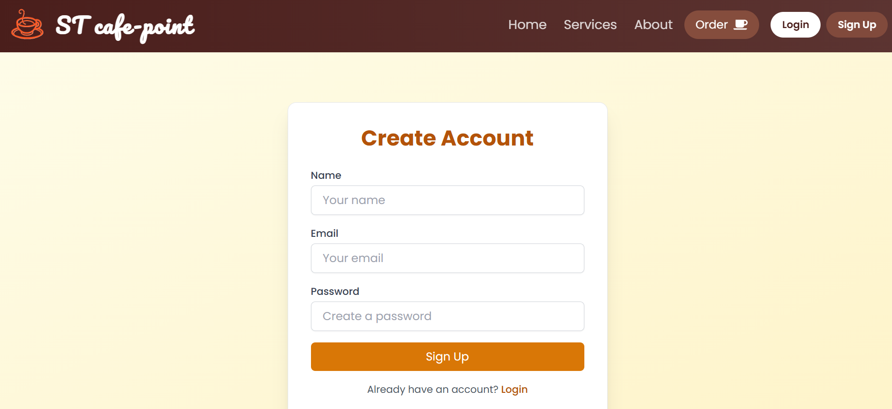

Login

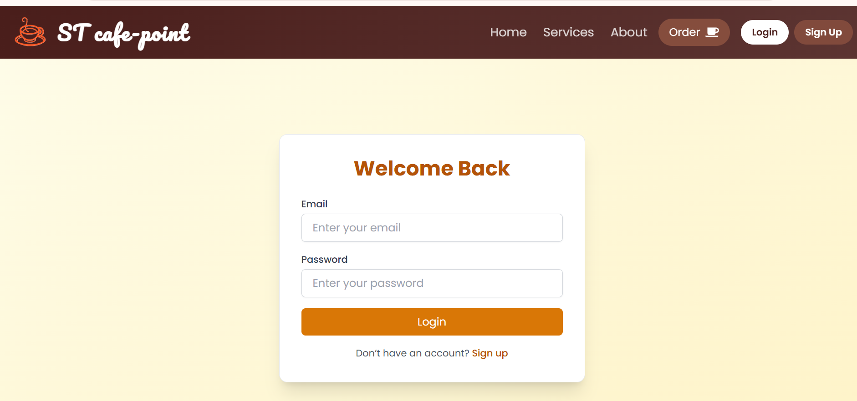

Order button

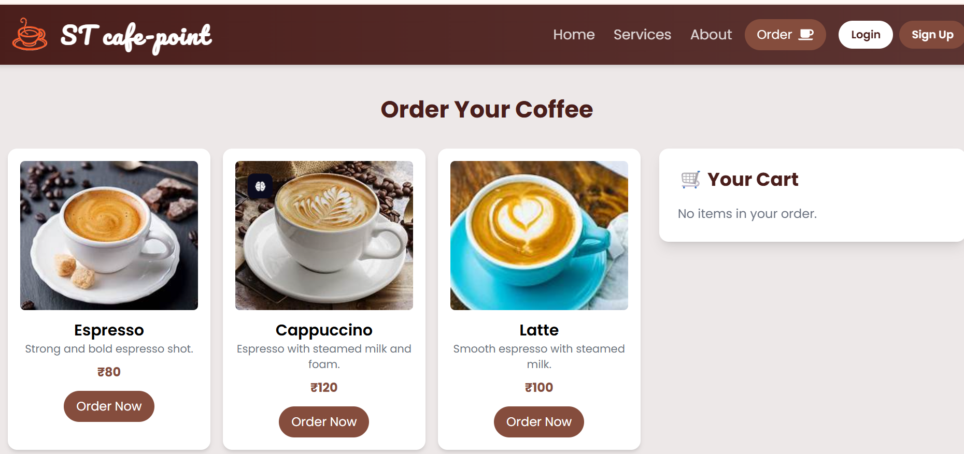

Order page with your cart

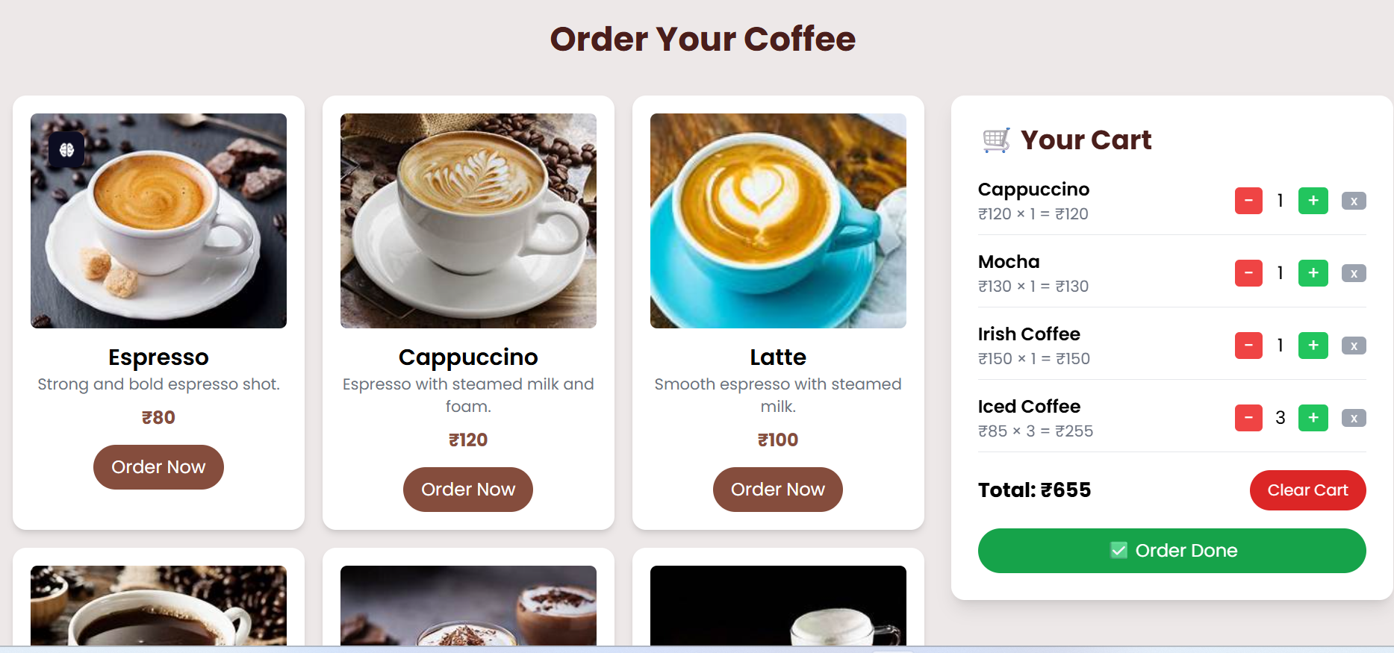

Order done summary

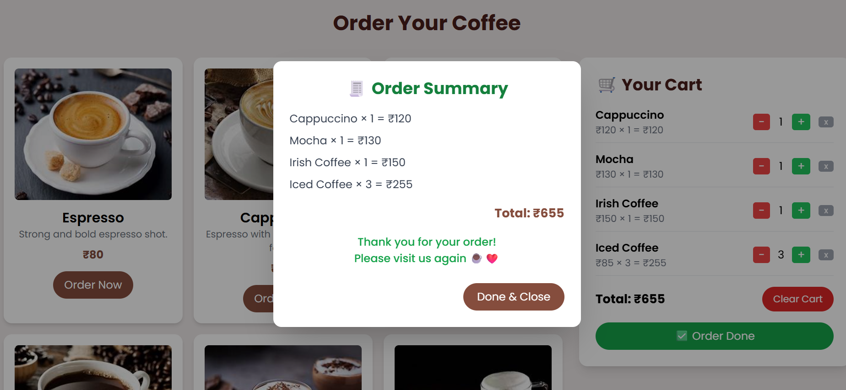

***Cammands***

**1. Backend**

cd backend

npm install

npm start

**2. Frontend**

cd frontend

npm install

npm start